An Analysis of Modern Browser Security Mechanisms and Their Practical Exploitation
Introduction
The modern web is a dynamic and complex ecosystem, a global platform for commerce, communication, and information exchange. This complexity, however, creates an inherent tension between functionality and security. While server-side vulnerabilities in databases and application logic have historically received significant attention, a robust security posture is impossible without a deep understanding and correct implementation of client-side, browser-enforced security mechanisms.¹ The browser acts as the final execution environment for web applications, making it the ultimate battleground where security policies are enforced and attacks are either thwarted or succeed.
This report posits that browser security is a multi-layered defense system. Foundational mechanisms such as the Same-Origin Policy (SOP), Content Security Policy (CSP), and process sandboxing act as concentric rings of protection around the application's core logic and data. State and session information, often managed via HTTP Cookies, represents the sensitive data that these layers are designed to protect. The practical failure of one layer, as will be demonstrated, underscores the critical importance of the others in preventing a total system compromise.
To explore this thesis, the report is structured in two parts. Part I provides a deep theoretical analysis of four foundational security concepts: the imperative of web security, the function and security of HTTP Cookies, the principles of the Same-Origin Policy and Content Security Policy, and the architecture of Browser Sandboxing. Part II transitions from theory to practice, presenting a detailed, hands-on lab report. This section documents the exploitation of specific vulnerabilities within the OWASP Juice Shop, a web application intentionally designed for security training. By demonstrating these exploits, the report will provide tangible evidence of how theoretical security concepts manifest—and can fail—in a real-world context.
Part I: Foundational Concepts in Browser and Web Security
The Imperative of Web Security
Before delving into specific browser mechanisms, it is essential to establish a comprehensive understanding of what web security entails and why it is a critical discipline in modern computing.
Defining Web Security
Web security is the collection of protective measures, protocols, and best practices designed to safeguard users, devices, data, and the wider network infrastructure from internet-based threats and cyberattacks. It is a multifaceted field that encompasses the security of websites, web applications, and web services. The objectives of web security are best understood through the lens of the Confidentiality, Integrity, and Availability (CIA) Triad, a core model of information security.
- Confidentiality: Ensuring that sensitive information is not disclosed to unauthorized individuals, entities, or processes. Web attacks like data breaches directly compromise confidentiality.
- Integrity: Maintaining the consistency, accuracy, and trustworthiness of data over its entire lifecycle. Attacks such as website defacement or unauthorized data modification violate integrity.
- Availability: Ensuring that systems and data are accessible to authorized users when needed. Denial-of-Service (DoS) attacks are a primary threat to availability.
A failure in web security can gravely damage the reputation of an organization and erode user trust, leading to direct financial loss and long-term consequences.
The Modern Threat Landscape
The need for robust web security is driven by a diverse and constantly evolving threat landscape. Cyberattacks against web-facing assets are common and can result in severe consequences, from website defacement to the complete compromise of sensitive customer data. A brief taxonomy of prevalent threats illustrates the scope of the challenge:
- Malware: An umbrella term for malicious software, including viruses, worms, trojans, and ransomware. Malware often infiltrates a system through a compromised website, either via a malicious link or an unwanted download, and can be used to steal data, disrupt operations, or hold systems hostage for a ransom.
- Social Engineering: The psychological manipulation of people into performing actions or divulging confidential information. Phishing is the most common form, where attackers use deceptive emails or messages, often impersonating a trusted entity, to trick users into revealing login credentials or financial information.
- Injection Attacks: A class of vulnerabilities where an attacker provides untrusted input to a program, which is then processed as part of a command or query.
  - SQL Injection (SQLi): Attackers insert malicious SQL queries into input fields, allowing them to bypass authentication, read, modify, or delete data in the application's database.
  - Cross-Site Scripting (XSS): Attackers inject malicious scripts (usually JavaScript) into a trusted website. When other users visit the site, their browsers execute the script, which can be used to steal session tokens, deface the site, or redirect users to malicious pages.
- Denial-of-Service (DoS) and Distributed Denial-of-Service (DDoS) Attacks: These attacks aim to make a machine or network resource unavailable to its intended users by overwhelming it with a flood of internet traffic. In a DDoS attack, this traffic originates from many different sources (often a botnet of compromised computers), making it difficult to block.
These threats are not isolated; they are often linked in a sequence of events known as an attack chain. For instance, an attacker might begin with a phishing email containing a link that exploits a Reflected XSS vulnerability on a trusted website.The XSS payload could be designed to steal the user's session cookie. With this stolen cookie, the attacker can hijack the user's session, impersonate them, and gain unauthorized access to their account and data. This progression from social engineering to code injection to account takeover demonstrates that web security is not about defending against a single threat but about building a layered defense that can disrupt this chain at multiple points.
HTTP Cookies: State, Session, and Security
At the heart of the modern interactive web is the need to maintain state. The Hypertext Transfer Protocol (HTTP) is inherently stateless, meaning each request from a client to a server is treated as an independent transaction, unrelated to any previous request. To overcome this limitation and enable features like user logins and shopping carts, HTTP cookies were introduced.
Core Functionality
A cookie is a small piece of data that a server sends to a user's web browser. The browser stores this data and sends it back to the same server with subsequent requests.⁹ This mechanism allows the server to "remember" information about the user's session. The primary uses for cookies fall into three categories ⁹:
- Session Management: Tracking user login status, shopping cart contents, or other session-specific data. A server can issue a cookie with a unique session identifier upon successful login, and this identifier is sent with every subsequent request to maintain the authenticated state.
- Personalization: Storing user preferences, such as language, theme, or other custom settings, to provide a tailored experience on return visits.
- Tracking: Recording and analyzing user behavior across a site or even multiple sites (in the case of third-party cookies) for analytics or advertising purposes.
A server creates a cookie by sending a Set-Cookie HTTP response header. For example:
Set-Cookie: sessionID=31d4d96e407aad42
The browser then stores this sessionID and includes it in future requests to that server in a Cookie request header:
Cookie: sessionID=31d4d96e407aad42
Security-Critical Attributes
While the name-value pair is the core of a cookie, its security is governed by a set of attributes included in the Set-Cookie header. Misconfiguration of these attributes can lead to serious vulnerabilities.
- Secure: This attribute is a boolean flag that instructs the browser to only send the cookie over an encrypted HTTPS connection. If the Secure flag is present, the browser will not send the cookie with an unencrypted HTTP request. This is a critical defense against Man-in-the-Middle (MitM) attacks, where an attacker on the same network could otherwise intercept the cookie in plaintext.¹³
- HttpOnly: This attribute is another boolean flag that provides a crucial defense against XSS attacks. When a cookie is marked as HttpOnly, it cannot be accessed by client-side scripts through the document.cookie API. This means that even if an attacker successfully injects a malicious script into a page, that script cannot read and exfiltrate sensitive cookies like session tokens, thus preventing session hijacking.
- Domain and Path: These attributes define the scope of the cookie, controlling which URLs it is sent to.
  - The Domain attribute specifies the hosts to which the cookie will be sent. If unspecified, it defaults to the host of the origin server, but not its subdomains. If a developer sets a permissive domain like Domain=example.com, the cookie will be sent to all subdomains (e.g., app.example.com, insecure-app.example.com). This can be dangerous, as a vulnerability on a less secure subdomain could lead to the compromise of cookies for the entire parent domain.⁹
  - The Path attribute indicates the URL path that must exist in the requested URL. For example, Path=/app means the cookie will be sent for requests to /app/profile but not to /other-app/. Setting the path too broadly (e.g., Path=/) can cause the cookie to be sent to other applications on the same server, creating a similar risk as a broad domain.¹³
- Expires and Max-Age: These attributes control the cookie's lifetime. If neither is set, the cookie is a session cookie and is deleted when the browser session ends. If Expires (specifying an exact expiration date) or Max-Age (specifying a duration in seconds) is set, the cookie becomes a persistent cookie stored on the user's disk. For sensitive session information, it is crucial to use session cookies or set a reasonably short lifetime to limit the window of opportunity for an attacker if a cookie is compromised.
- SameSite: This is a powerful attribute designed to mitigate Cross-Site Request Forgery (CSRF) attacks. CSRF tricks a victim's browser into making a malicious request to a site where the user is authenticated. The SameSite attribute controls whether a cookie is sent with cross-site requests. It has three possible values :
  - Strict: The browser will only send the cookie for same-site requests. It will not be sent on any cross-site request, including when a user clicks a regular link from an external site. This is the most secure option but can impact user experience.
  - Lax: The browser will not send the cookie on cross-site subrequests (e.g., requests to load images or frames) but will send it when a user navigates to the URL from an external site (i.e., by following a link). This is the default value in most modern browsers, offering a good balance of security and usability.
  - None: The browser will send the cookie on all requests, both same-site and cross-site. This value is required for cookies used in a third-party context (e.g., tracking pixels, embedded content). If SameSite=None is used, the Secure attribute must also be set.
The following table summarizes these critical attributes and the threats they are designed to mitigate.
Attribute | Purpose | Threat Mitigated | Example
Secure | Ensures cookie is sent only over HTTPS. | Man-in-the-Middle (MitM) sniffing. | Set-Cookie: id=123; Secure
HttpOnly | Restricts access from client-side scripts. | XSS-based session hijacking. | Set-Cookie: session=xyz; HttpOnly
SameSite=Strict | Prevents cookie from being sent on all cross-site requests. | Cross-Site Request Forgery (CSRF). | Set-Cookie: session=xyz; SameSite=Strict
SameSite=Lax | Prevents cookie on cross-site subrequests but allows on top-level navigation. | CSRF (with some exceptions for usability). | Set-Cookie: session=xyz; SameSite=Lax
Domain | Defines the host to which the cookie will be sent. | Cookie leakage to less secure subdomains. | Set-Cookie: id=123; Domain=secure.example.com
The Same-Origin Policy (SOP): The Web's Foundational Security Boundary
The Same-Origin Policy is arguably the most critical security concept in the modern web browser. It is a fundamental boundary that prevents documents and scripts loaded from one origin from interacting with resources from another origin in arbitrary ways.¹⁶
Defining an "Origin"
To understand the policy, one must first have a precise definition of an "origin." An origin is defined by a tuple of three components: the scheme (protocol), host (domain name), and port number of a URL. Two URLs are considered to have the same origin if and only if all three of these values are identical.
For example, consider the URL https://www.example.com/dir/page.html:
- Scheme: https
- Host: www.example.com
- Port: 443 (implied for HTTPS)
A script from this origin can freely interact with https://www.example.com/dir2/other.html. However, it would be considered cross-origin with respect to all of the following:
- http://www.example.com (different scheme)
- https://www.sub.example.com (different host)
- https://www.example.com:8080 (different port)
Policy Mechanics: Allow Embedding, Block Reading
The SOP is not a blanket ban on all cross-origin interactions. The web is designed for composite documents, where a single page may embed resources from many different origins. The policy generally makes a distinction between embedding and reading :
- Cross-Origin Writes and Embeds (Generally Permitted): A web page can typically embed cross-origin resources. This includes:
  - Images via <img>
  - Stylesheets via <link>
  - Scripts via <script>
  - Videos and audio via <video> and <audio>
  - Documents via <iframe>
  - Form submissions to a cross-origin endpoint.
- Cross-Origin Reads (Generally Blocked): This is the core enforcement of the SOP. While a resource can be embedded, a script from one origin is blocked from reading the contents of a resource from another origin. For example, a script on attacker.com can embed your-bank.com in an <iframe>, but it cannot use JavaScript to access the DOM of that iframe to read your account balance. Similarly, it can load an image from another origin, but it cannot access the raw pixel data of that image.
This "deny read by default" behavior is what prevents a malicious website you have open in one tab from making requests to your online banking portal in another tab and exfiltrating your private data.It is a foundational pillar that isolates web content.
This policy is not a library or a feature that developers "enable"; it is the default-secure state of the web. The evolution of web applications, particularly Single Page Applications (SPAs) that need to fetch data from APIs hosted on different domains, necessitated a way to safely relax this restriction. This led to the development of Cross-Origin Resource Sharing (CORS), a mechanism where a server can use HTTP headers (like Access-Control-Allow-Origin) to explicitly tell the browser that it is permissible for a web page from a specific different origin to read its responses. Therefore, modern cross-domain development is not about "bypassing" SOP, but rather the practice of using standardized, server-approved protocols for its controlled and secure relaxation.
Content Security Policy (CSP): A Granular Defense Against Code Injection
While the Same-Origin Policy provides a broad boundary between sites, the Content Security Policy (CSP) offers a more granular, fine-grained set of controls over what resources a specific page is allowed to load and execute. CSP is implemented as an HTTP response header (Content-Security-Policy) and acts as a powerful defense-in-depth mechanism, primarily to mitigate Cross-Site Scripting (XSS) and other code injection attacks.
Implementation and Directives
A CSP is a whitelist of trusted sources. The policy is composed of one or more directives, each controlling a specific type of resource or behavior. When a browser receives a page with a CSP header, it will enforce the policy, blocking any resources that are not explicitly allowed.²²
Key directives include :
- default-src: A fallback directive for most other fetch directives. If another directive like script-src is not specified, the value of default-src is used. A common secure starting point is default-src 'self', which allows resources only from the same origin.
- script-src: This is the most critical directive for preventing XSS. It defines the permitted sources for JavaScript files. By restricting this to trusted, known sources, an attacker's injected <script> tag pointing to a malicious domain will be blocked by the browser.
- style-src, img-src, font-src, media-src: These directives control the allowed sources for CSS stylesheets, images, fonts, and multimedia files, respectively.
- frame-ancestors: This directive specifies which origins are allowed to embed the current page in an <iframe>, <frame>, <object>, etc. Setting frame-ancestors 'none' completely prevents the page from being framed, providing a robust defense against clickjacking attacks, where an attacker overlays a transparent malicious page on top of a legitimate one.²³
- object-src: Restricts sources for plugins like Flash. For modern applications, this is almost always set to 'none' to reduce the attack surface.
- report-uri / report-to: These directives instruct the browser to POST a JSON-formatted report of any policy violations to a specified URL. This turns CSP from a purely blocking mechanism into a valuable monitoring and reconnaissance tool, allowing developers to discover injection attempts or identify parts of their application that are not compliant with the policy.²⁵
An example of a moderately strict policy might look like this:
Content-Security-Policy: default-src 'self'; script-src 'self' https://apis.google.com; img-src *; frame-ancestors 'none';
This policy allows any resource from the same origin, allows scripts from the same origin and apis.google.com, allows images from anywhere, and prevents the page from being framed.
A strict CSP does more than just block attacks at runtime; it fundamentally improves the security posture of the codebase by enforcing secure development patterns. For instance, a strict policy will disallow inline scripts (<script>alert(1)</script>) and inline event handlers (<button onclick="...">). This forces developers to move all JavaScript into external .js files, which are then whitelisted via script-src.²⁶ It also blocks the use of dangerous functions like eval(). By making these insecure shortcuts impossible, CSP acts as an enforcement mechanism for secure coding standards, improving the baseline quality and security of the code itself.
Browser Sandboxing: Isolating and Containing Malicious Processes
If all other defenses fail—if input validation is bypassed, SOP is misconfigured, and CSP is circumvented—the final line of defense within the browser is the sandbox. Sandboxing is a security model that isolates running programs in a highly restricted environment, limiting the resources they can access and the actions they can perform.²⁷
Architectural Principle of Isolation
Modern browsers like Google Chrome, Firefox, and Edge are built on a multi-process architecture. Instead of running the entire browser in a single monolithic process, they split tasks into several distinct processes with different privilege levels.²⁹ A typical architecture includes:
- The Browser Process: The main, high-privilege process that manages the UI (windows, tabs, address bar) and coordinates with all other processes.
- Renderer Processes: Low-privilege processes responsible for rendering web content. Each tab or site is typically given its own renderer process. This is where HTML parsing, CSS styling, and JavaScript execution occur.
- GPU Process: A process for handling GPU-accelerated tasks, isolated from the renderers.
- Plugin Processes: Processes for handling plugins like Flash (now largely deprecated).
The renderer process is the heart of the sandbox. It is intentionally designed to be untrustworthy because it executes code from the internet. The sandbox uses operating system-level features to create a restrictive environment for this process, blocking it from directly accessing the file system, making arbitrary network connections, or interacting with sensitive user devices.²⁸ If a renderer process needs to perform a privileged action, like saving a file, it must make a request to the high-privilege browser process, which can then validate the request and mediate the action.
The effectiveness of this architectural defense has created a security "arms race." In the past, a single remote code execution (RCE) vulnerability in a browser's rendering engine was often a "game over" event, giving an attacker full control over the user's machine. Today, because of sandboxing, achieving RCE within the renderer process is only the first step. The attacker's code is trapped within the sandbox, unable to cause significant harm to the host system. To achieve a meaningful compromise, the attacker must now find and exploit a second, entirely different vulnerability—a sandbox escape. This second exploit typically targets a bug in the operating system kernel or in the Inter-Process Communication (IPC) channel between the renderer and the browser process. The need to chain two or more complex exploits together dramatically increases the difficulty, cost, and rarity of a successful, full browser compromise, showcasing the profound impact of sandboxing as a security control.
Part II: Practical Exploitation in the OWASP Juice Shop Environment
To bridge the gap between theoretical knowledge and practical application, this section details the exploitation of several vulnerabilities within the OWASP Juice Shop. The Juice Shop is an intentionally insecure web application developed by the Open Web Application Security Project (OWASP) for security training purposes. It is built with modern technologies (Node.js, Express, and Angular) and features a wide range of vulnerabilities that reflect real-world security flaws.³⁰ Progress is tracked via an in-application Score Board, which confirms when a challenge has been successfully completed.³³
The following table provides an overview of the challenges selected for this report, linking them to the foundational concepts discussed in Part I.
Challenge Name | Difficulty | Vulnerability Category | Key Concepts Demonstrated
Login Admin | Medium | Injection (SQLi) | Server-Side Input Validation Failure
DOM XSS | LOW | XSS | Client-Side Script Injection, DOM Manipulation
Lab : Login Admin (SQL Injection)
- Challenge: Log in with the administrator's user account.³²
- Relevant Concepts: SQL Injection, Authentication Bypass.
- Vulnerability Analysis: This challenge exploits a classic SQL Injection vulnerability in the user login form. The application backend constructs the SQL query for authentication by directly concatenating the user-provided email and password into the query string, without using parameterized queries or proper escaping. The underlying query is structured similarly to: $SELECT * FROM Users WHERE email = '${userInputEmail}' AND password = '${hashedPassword}'.³⁵ An attacker can provide a specially crafted email input that alters the logic of this query. The payload ' or 1=1-- is designed to close the string for the email field, introduce a new condition (OR 1=1) that is always true, and then comment out the rest of the query (--), effectively bypassing the password check entirely.³⁵
- Step-by-Step Exploitation:
  - Navigate to the OWASP Juice Shop and access the "Account" -> "Login" page.
  - In the "Email" input field, enter the SQL injection payload: ' or 1=1--.
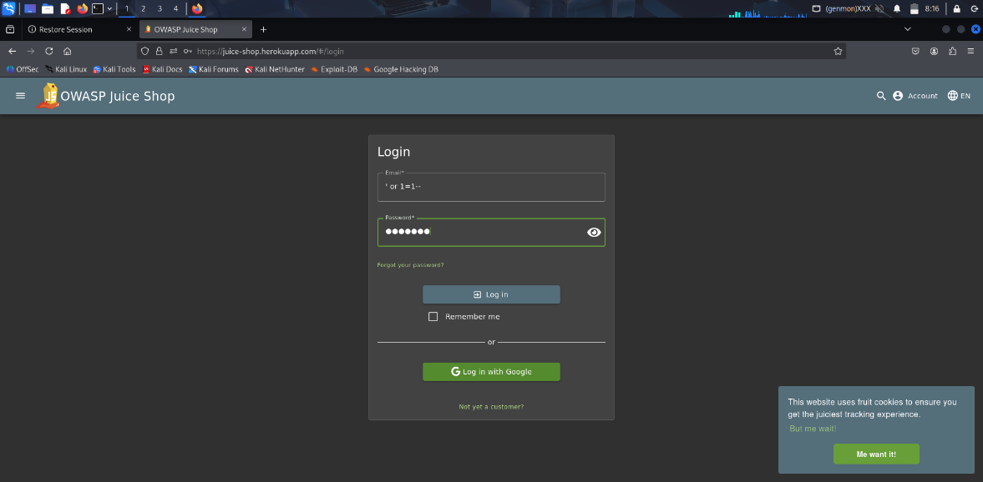

  - In the "Password" field, enter any non-empty string (e.g., "password").
  - Click the "Log in" button.

- Evidence of Completion: Upon successful submission, the application logs the user in as the administrator (user ID 0). A notification banner appears at the top of the screen confirming that the "Login Admin" challenge has been solved. 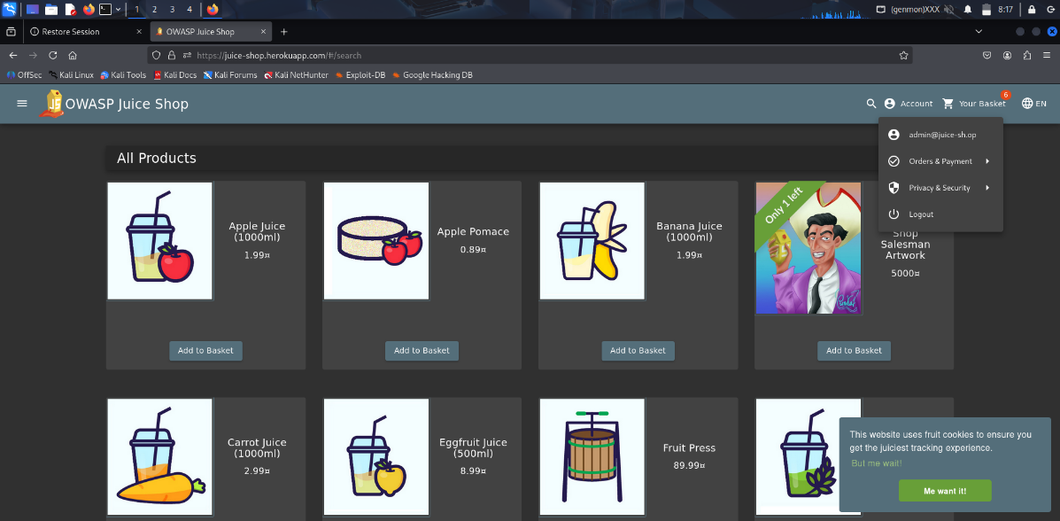

Lab : DOM XSS (Cross-Site Scripting)
- Challenge: Perform a DOM XSS attack with <iframe src="javascript:alert('xss')">.³⁸
- Relevant Concepts: DOM-based Cross-Site Scripting (XSS), Client-Side Scripting, Lack of Output Encoding/Sanitization.
- Vulnerability Analysis: This challenge exploits a DOM-based XSS vulnerability in the application's search functionality. When a user performs a search, the search term is taken from the URL query parameter and written directly into the page's Document Object Model (DOM) without being properly sanitized or encoded. An attacker can craft a search query that contains HTML and JavaScript. The provided payload, <iframe src="javascript:alert('xss')">, creates an <iframe> element. The src attribute of this iframe uses the javascript: pseudo-protocol, which causes the browser to execute the JavaScript code that follows, triggering an alert box.³⁴
- Step-by-Step Exploitation:
  - On the main page of the Juice Shop, locate the search icon in the navigation bar and click it to open the search field.
  - In the search input field, paste the exact payload: <iframe src="javascript:alert('xss')">.

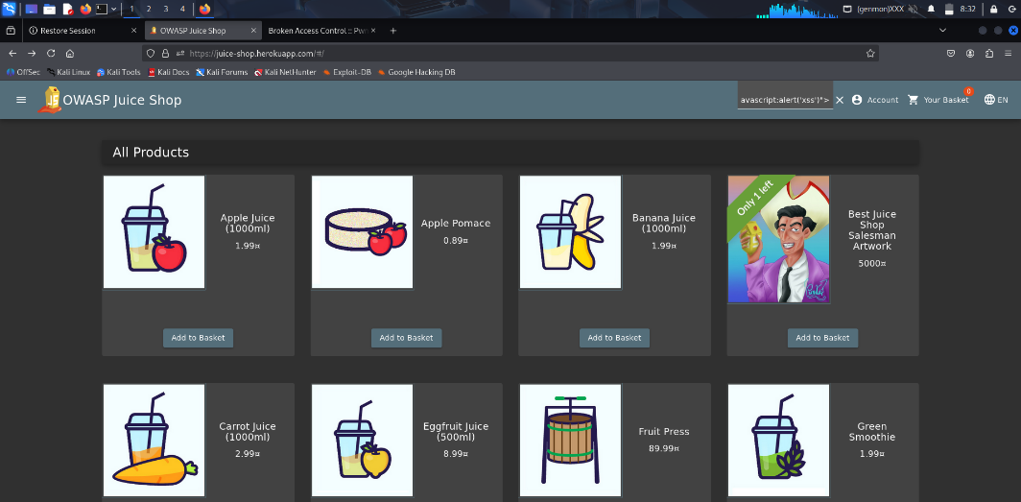

  - Press the Enter key to submit the search.
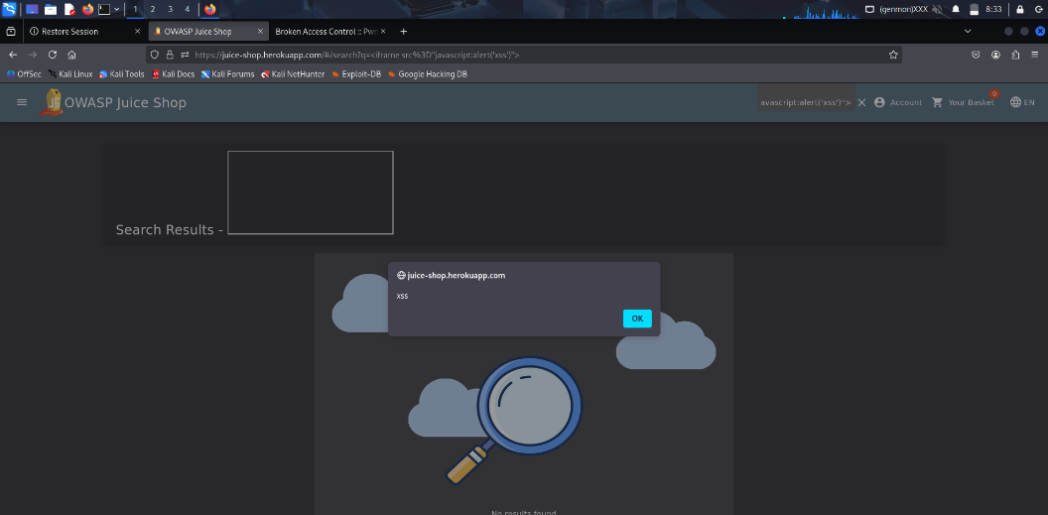

- Evidence of Completion: Immediately after submitting the search, the browser will execute the script, and a JavaScript alert dialog box with the text "xss" will appear on the screen. The "DOM XSS" challenge solved notification will also be displayed.

Conclusion
This report shows that modern browser security relies on layered defenses—cookies, the Same-Origin Policy, CSP, and sandboxing—and that practical testing is essential to reveal real-world weaknesses. The two labs you completed (Login Admin — SQL Injection and DOM XSS — Cross-Site Scripting) demonstrate how a single server-side or client-side failure can bypass higher-level protections and lead to account compromise or code injection. Hands-on exercises like these reinforce that theory alone isn’t enough: secure web apps require correct implementation at every layer and regular, practical testing to find and fix gaps.

